Assignment 3 UML Relationship

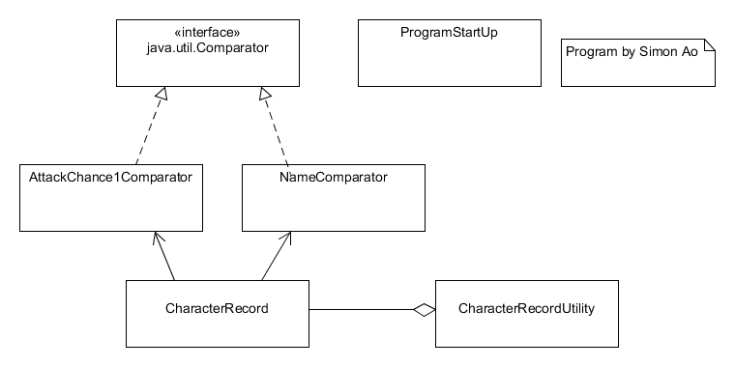

1. AttackChance1Comparator implement Comparator.
2. NameComparator implement Comparator.
3. CharacteRecord Association AttackChance1Comparator and NameComparator.
4. CharacterRecordUtility has a CharacterRecord.

